Saint Ephrem’s Newsletter… for you!
Parish Ministry Office- 215-639-4332 or mjbihm3@gmail.com

To our dear Homebound Parishioners,
This month we continue to befriend St. Katharine Drexel, our hometown saint. Perhaps some of her insights will be a support for you as the Lenten 2020 season begins.
“God does not expect me to work alone nor to suffer alone, not to make efforts alone. The stores of His mercy are infinite, and he ever gives more to the generous soul.”- St. K. D.
_________________________________________________ My response: My moments of effort to be patient and calm in the midst of everyday struggles…can be a very good Lenten sacrifice! 
Look at the crucifix- “see the Savior dying for our love.”-St K.D.
St. Katharine Drexel had great devotion to the Holy Face and an intense regard for the Passion of Christ. Her love of God was very personal; she felt His pain and suffering greatly.
My response: Can I try to see the Face of Christ in the very faces that come across my path today. Everyone is carrying a cross—most often a very hidden one.
“There is nothing little in what is done for God.” –St. K.D.
My Response: This Lent I may not be able to do big things…but there are many little things I can choose to do… I do not have to FAST due to my age and medical situation but I can…
“FAST interiorly from uncharitable thoughts and words.. FAST from unkind, ungentle, want of meekness in words to another…”-St. K.D.
“It is hard to suffer patiently and lovingly. Offer it as a prayer for mercy”- St. K.D.
My Response:  When the hours of the day bring me aches and pains or pangs of loneliness…consciously hand them to Jesus and ask for His mercy. 
“We can all take comfort in the thought that He who was all –perfect does not ask a ‘finished work,’ but He does ask for
the continued effort and is pleased with our desire…” St. K.D.
My Response:  When I become conscious of my own sins and failures, flaws---I will remind myself that I am a work in progress and the God is not finished with me yet. I will see myself in the hands of God and trust his patience! 
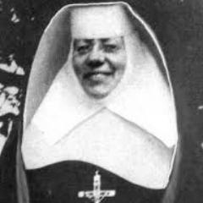
St. Katharine Drexel, pray for us!
Feast Day: March 3

“All that occurs daily is to be used
as an opportunity to bring
His life into our life.”
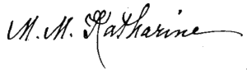

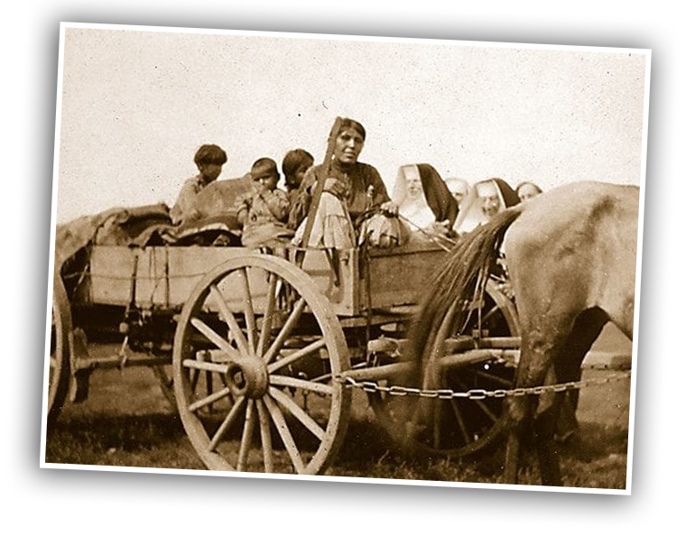

Compiled with the gracious help of Stephanie Morris, ASBS, Ph. D., C.A.

