Saint Ephrem’s Newsletter… for you!
Parish Ministry Office- 215-639-4332 or mjbihm3@gmail.com

To all our wonderful Parishioners at home…
The summer has gone by so very quickly and now we begin our newsletter once again. I do hope all is well with each of you—yes, we have had a rather uncomfortable summer, weather-wise. Hopefully, you have had a pleasant summer.
You probably have heard that our Father Katziner has had heart surgery but he is doing very well now. He hopes to return to St. Ephrem’s sometime in September. We have been praying for him daily and really miss him and his caring ways around the parish. We will be so happy to see him again.
Lots of concerns fill our minds and world today. Just this morning I was thinking about so many things and happened to look up toward our choir loft. As you may recall there is a very beautiful stained glass window of Jesus, the Good Shepherd!
Today our parish, our country and our world are filled with many who need the Lord’s help. We believe that Jesus not only welcomes but seeks out those who are in need. Perhaps we are invited to turn to Jesus---answering the invitation: “Come to me, all who are tired and heavily burdened…”
Please know that each of you are prayed for daily and mentioned in our Intercessory Prayer each and every Sunday.
If you are in need of a Eucharistic Minister to visit and bring you the Eucharist, please contact me and do not hesitate. It is our privilege to carry the Lord Jesus to you, since you are not able to join us for the Eucharist.

Lord of the 23rd Psalm,
I have known death,
and you have refreshed my soul.
I have known fear,
and you have comforted me.
I have known hunger,
and you have set a feast before me.
In the darkest valley
no calamity of humankind or nature has separated us.
Teach me to walk as you walk
Beside those in mourning
so that they will know joy,
Beside those in fear
that they will know comfort,
Beside those in hunger
that they will feast until their cup overflows.
As your goodness and love follow me,
May mine follow my neighbor
That the threat of the worst terrors
May turn to the knowledge of the comforts of
the house of the Lord,
Where you have invited us to dwell forever.
And so let me strive to help build on earth
What you have promised us in heaven.
In the face of all calamity, present and yet to come,
Let me lead my neighbor beside quiet waters,
The quiet waters of the Good Shepherd.
--Catholic Relief Services

--

St. Ephrem School opens for our children and teachers this coming week. We pray for the safety and health of all of our children and teachers. We pray for our young adults who are going off to college for the first time.
Feast of the Exaltation of the Holy Cross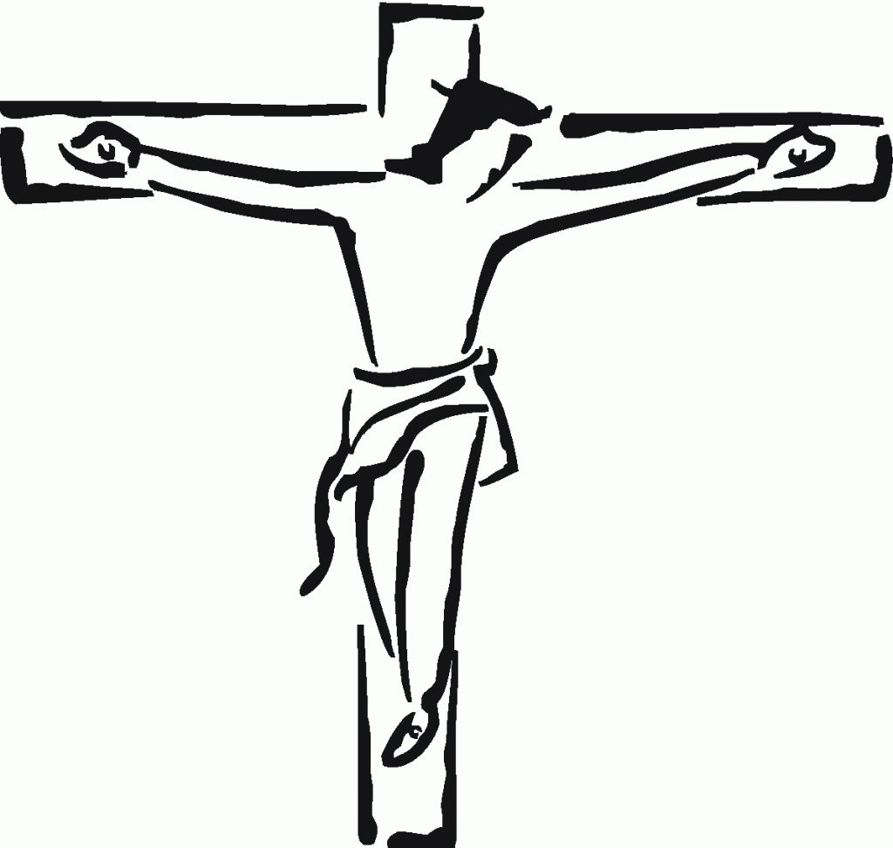Sept. 14

Good and gentle Jesus, I kneel before you, I see and ponder your five wounds. Imprint on me this image of yourself. Fulfill the deep desires of my heart. Give me faith, hope and love, repentance for my sins, and the strength to serve your people with respect and love. Amen
Amen.

