May 2019
May is the Month of Our Blessed Mother, Each day, may be REMEMBER that she is our Mother, who attends to our cries and our needs. Call upon her!
Sunday | Monday | Tuesday | Wednesday | Thursday | Friday | Saturday
28 | 29 | 30 | 1 | 2 | 3 | 4
Divine Mercy Sunday | 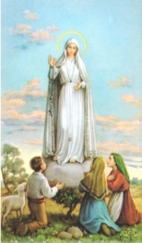  Our  Lady  of  Fatima  May 13 | St. Joseph,  the  Worker  May 1 | St. Joseph, the Worker  St. Joseph, bless our fathers both living and deceased! | St. Athanasius  Risen Jesus, help me to trust in your love for me at all times! | Sts. Philip and James  Jesus, strengthen my faith. Lord, I do believe, help my  Unbelief! | First Saturday  Mary, my mother,  help me to turn to you with all my concerns and worries.
5 | 6 | 7 | 8 | 9 | 10 | 11
Help me to remember your words, Jesus, “It is I, Do not be afraid.” No storm can separate me from your love. | The Risen Jesus is close to us at all times. Jesus, help me to remember you are always with me. | Jesus is the Bread of Life. Whoever comes to him will never be hungry.  Let Jesus know what you need. | Go close to Jesus in your heart today. He promised he would never reject anyone who comes to him. | Whoever believes has eternal life, Jesus promised!  Jesus, I want to believe in your promises. Help me today! | Whoever feeds on Jesus’ words and lives by them…has eternal live. Help me to remember to live in the spirit of the Gospel. | Jesus, to whom shall we go? You alone have the words of eternal life. I do believe!
12 | 13 | 14 | 15 | 16 | 17 | 18
Happy Mother’s Day  We remember and pray for all of our dear Mothers, both living and deceased. | Our Lady of Fatima  Pray today:  “My God, I believe, I adore, I hope, and I love You.”  Prayer taught to the children at Fatima by the angel | St. Matthias  Jesus asks us to remain in his love.  Today, ask him to show you how to stay close to him in a special way. | St. Isadore  Jesus, Light of the world, shine in my heart today and the hearts of those I love. | St. Brendan the Navigator  Jesus, guide me over the waters of this day. Help me to be faithful to you. | Jesus says, “Do not let your hearts be troubled.”  Today, share your worries with Jesus/. | Jesus said, “If you ask anything of me in my name, I will do it.  What is the most important thing you ask Jesus to do?
19 | 20 | 21 | 22 | 23 | 24 | 25
Jesus asks us above all to “love one another.”  Let us ask him this day to give us this grace in a special way. | Jesus wants to make his home in us. Jesus, please come and show me how to become a good dwelling place for you. | “Peace I leave with you, my peace I give to you.”  Sit awhile and ask him to help you to find that peace he gives. | St. Rita of Cascia  Jesus is the true vine…He wants to to stay joined to him so we have life.  Jesus, You are my life. Live in me! | “I have told you all this so that my joy may be in you…”  Jesus, help me to let your joy fill my heart! | Jesus calls us his friends!  Jesus, help me to value your friendship and to be a good friend to others. | Jesus has chosen us to be close to him,  Jesus, help me to know you and your closeness to me at all times.
26 | 27 | 28 | 29 | 30 | 31
The Holy Spirit comes to remind us of all Jesus told us.  Come, Holy Spirit,remind me each and every day! | Memorial Day  Jesus, bless all those who gave their lives for us. Help all veterans in every way! | Jesus, you promised the gift of your Spirit.  Your Spirit is with us and gives us life! | Come, Holy Spirit, fill the hearts of the faithful and enkindle in us the fire of your love. | Ascension of Our Lord  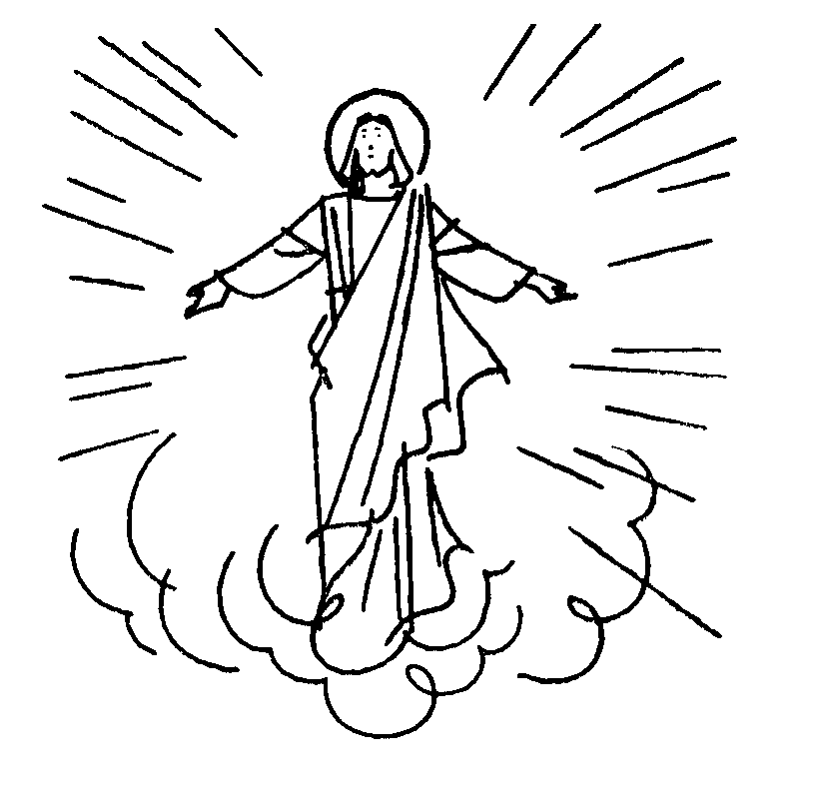  Behold! I am with you always until the end of the world.” | Visitation of the  Blessed Virgin Mary  Mary, help me to be aware of the others in my life. | 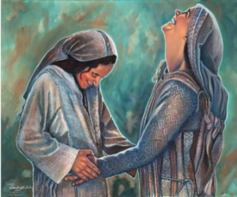
© Calendarpedia® www.calendarpedia.com |  |  |  |  |  | Data provided 'as is' without warranty

