Saint Ephrem’s Newsletter… for you!
Parish Ministry Office- 215-639-4332 or mjbihm3@gmail.com
To all our dear St. Ephrem’s Homebound Parishioners,
I am writing to each of you as we have just begun our fifty days of Easter…each of you and your intentions was remembered in every one of our Easter Masses.
We are now at the beginning of May, the beautiful month of spring flowers and above all, the month of Mary, our Mother!
Our school May Procession and Crowning of Our Lady’s Statue will be held on Friday, May 3, 2019 at 10 AM. Please be assured that your intentions will be remembered.
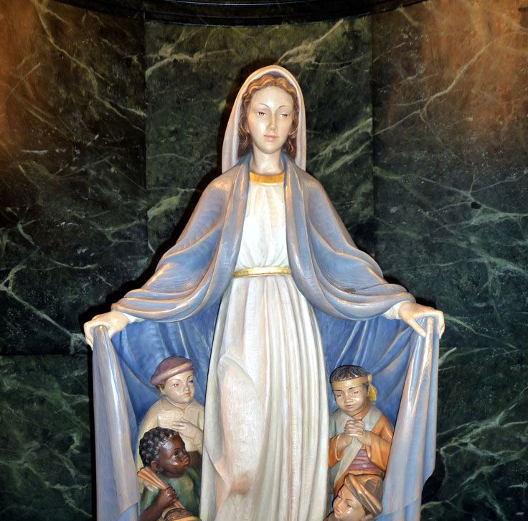
The Memorare

Remember, O most gracious Virgin Mary,
that never was it known
that anyone who fled to your protection,
implored your help, or sought your intercession was left unaided.
Inspired by this confidence, I fly unto you, O virgin of virgins, my Mother;
to you I come, before you I stand,
sinful and sorrowful.
Mother of the Word Incarnate, despise not my petitions, but in your mercy hear and answer me. Amen!

St. Ephrem’s Catechumens and CandCandidates
St. Ephrem’s Catechumens and Candidates…
At the Easter Vigil Mass, three individuals were baptized and received not only Baptism but also the sacraments of Holy Eucharist and Confirmation.
We welcome and congratulate…
Brandon Whalen
Brittany Lyons
Stansilava Staneva

as they join our Catholic family of St. Ephrem’s.
AND
On Sunday, April 28, eight individuals received the sacrament of Holy Eucharist and Confirmation at the 10:30 Mass.
Daniel J. Clemenson
Kadyn S. Geddes
Robert A. Guild, III
Laura Marie Klauder
Amber M. Klauder
Cashia M. Wineburg
Emily G. Wineburg
Jack F. Wineburg

Please keep them in your prayers!!!

Next Prayer Calendar and Newsletter will be sent in September. God bless you!

Prayer for the Sick…Loving God, Rock of strength for those who trust in you; comforter of those who call on you. Hear the cry of those who suffer from constant sickness of weakness, and embrace them in your loving arms. As you have united them to the suffering of Christ in the waters of Baptism, be their companion on the way of the cross, give them peace, and strengthen them with the vision of your kingdom. We make this prayer through Jesus. Amen ----Blessings and Prayers for Home and Family

