April 2019- |  |  |  |  |  | `
Sunday | Monday | Tuesday | Wednesday | Thursday | Friday | Saturday
 | 1 | 2 | 3 | 4 | 5 | 6
 | APRIL FOOLS DAY  Hear my prayer. You will restore my life when I turn to you. Thank you! | You know all things, Lord, you know how much I need you in my life…lead me! | Can a mother forget her infant, be without tenderness for the child of her womb? God says,  “ I will never forget you!” | ST. ISIDORE  Lord, open my eyes to the small gifts of your love for me today. Lord, open my eyes! | ST. VINDENT FERRER  Lord, help me to show mercy to all I meet today…as you show mercy to me. | FIRST SATURDAY  Mary, be close to me as I continue my Lenten journey of love. Guide me to Jesus!
7 | 8 | 9 | 10 | 11 | 12 | 13
5TH SUNDAY OF LENT  Jesus, I thank you for your patience with me. | Even though I may walk in the dark valley some days, I I know, Jesus, you are with me, leading me. | Lord, hear my prayer. Incline your ear to me; on the day I call, answer me speedily and help me to hear You. | Once again, Lord, I ask to know the path that leads me closer to You. Help me to trust in you with all my heart. | Lord, open my eyes to the beauty of this new spring day..such is your ever-present delight in me. | Jesus, help me to be quiet enough to accompany you as I recall your Passion next week.  Help me to be still and to listen. | Mary, be near to each one of us. Comfort us in all of our pains and concerns. You are ever our loving Mother.
14 | 15 | 16 | 17 | 18 | 19 | 20
PALM SUNDAY  HOLY WEEK BEGINS………………… | Lord Jesus, let me stay close to you during this coming week…thinking of you, loving you… | Lord, give me the grace to accompany you to the end of your  journey with a faithful  heart. | Deepen my trust in you…you poured out your life for me.  Help me to believe in your love for me. | HOLY THURSDAY  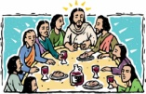  “Do this in  memory of me..” | GOOD FRIDAY  “Into your hands I comment my spirit.” | HOLY SATURDAY  Great Silence on earth today
21 | 22 | 23 | 24 | 25 | 26 | 27
EASTER SUNDAY  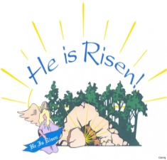 | EASTER MONDAY  Notice the new life all around you!...  Ask Jesus to show you the new life within you. | EASTER TUESDAY  Jesus, thank you for all---and for the promise of sharing Resurrection with me | EASTER  WEDNESDAY  Jesus, help me to rise from my the one thing that is holding me in chains. | EASTER THURSDAY  Jesus, I do believe that you are with me…leading the way. | EASTER FRIDAY  Jesus, just as you prepared breakfast for your apostles, you feed me with your Body and Blood. | EASTER SATURDAY  Help me to believe and carry your presence to all I meet today.
28 | 29 | 30
DIVINE MERCY  SUNDAY  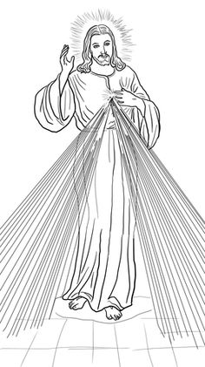  I trust in your mercy,  Jesus | ST.CATHERINE OF SIENA  Jesus, You are the Way---show me how to follow you  More closely. | The Paschal Candle (or Easter Candle) that leads us out of darkness in to the celebration of the Easter Vigil is the main symbol of the Easter season.The paschal candle is lit to represent the presence of the Risen Lord among us.  Throughout the year, the Easter candle will be lit at Baptisms and Funerals. It will also be lit throughout the Easter season. (Easter until Pentecost)
© Calendarpedia® www.calendarpedia.com

