Saint Ephrem’s Newsletter… for you!
Parish Ministry Office- 215-639-4332 or mjbihm3@gmail.com

Catholic Schools Week 2019 is “Catholic Schools: Learn. Serve. Le
CATHOLIC SCHOOLS WEEK- JAN. 27- FEB. 2
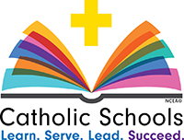
The theme for this year’s Catholic Schools Week is
“Catholic Schools: Learn. Serve. Lead. Succeed”
This year our educators at St. Ephrem School will take part in a Professional Development opportunity at the Franklin Institute entitled “Understanding the Brain”, a dynamic learning experience dedicated to empowering educators with critical knowledge in neuroscience to make informed, research-based decisions that advance student learning!


Dear St. Ephrem Parishioners, Just to keep in touch and promise a continued remembrance in our parish thoughts and prayers, I wanted to share with you some of the events that are taking place at St. Ephrem Parish….May the peace of Jesus fill your hearts this month of February!!!!!
On February 2, 2019, we will celebrate:
World Day of Prayer for Consecrated Life
In 1997, Pope John Paul II instituted a day of prayer for women and men in consecrated life. This day of prayer is attached to the Feast of the Presentation of the Lord, which is also known as Candlemas Day, the day on which candles are blessed symbolizing Christ who is the Light of the world. So, too, we pray that those in consecrated life will continue to reflect the light of Jesus to all people. You are invited to join with the whole Church as we pray for all those living a consecrated life.

World Day of the Prayer for the Sick
February 11 is World Day of the Sick, an observation started by Pope John Paul II as a way for believers to offer prayers for those suffering from illnesses. The day is meant to coincide with the commemoration of the feast of Our Lady of Lourdes. This feast was chosen because many pilgrims and visitors to Lourdes have reportedly been healed by the intercession of our Blessed Mother.
Our Lady of Lourdes, Pray for us!
Prayer for those in Consecrated Life
O God, throughout the ages you have called women and men to pursue lives of perfect charity through the evangelical counsels of poverty, chastity, and obedience.
We give you thanks
for these courageous witnesses of Faith and models of inspiration.
Their pursuit of holy lives teaches us to make a more perfect offering of ourselves to you. Continue to enrich your Church by calling forth sons and daughters who,
having found the pearl of great price,
treasure the Kingdom of Heaven above all things. Through our Lord Jesus Christ, your Son,
who lives and reigns with you
in the unity of the Holy Spirit,
one God, for ever and ever. Amen.
____________________

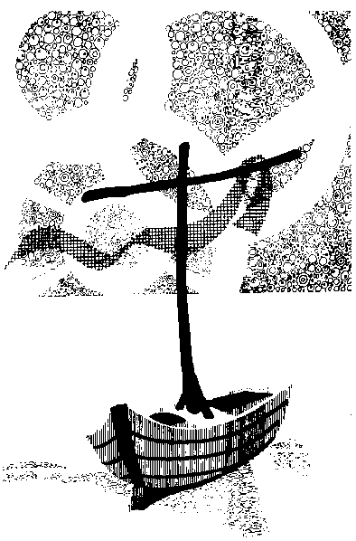

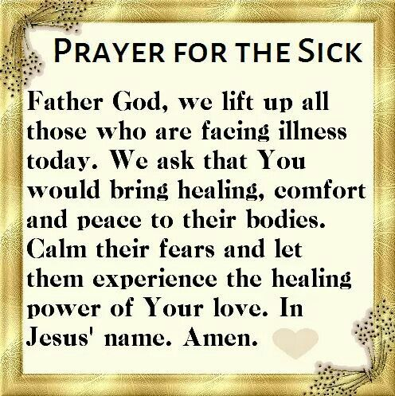

“Where there is no love, put love –

and you will find love.” St. John of the Cross

“There is only one happiness in life: to love and and be loved.” – George Sand

