September 2018
Sunday | Monday | Tuesday | Wednesday | Thursday | Friday | Saturday
We pray for all the intentions of our Church… | Camilla Chances will be sold after all Masses on Sept. 15-16 |  | 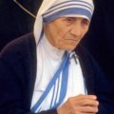 | 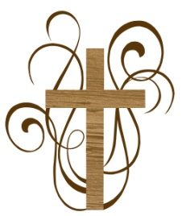 | 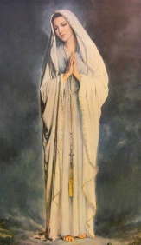 | 1  Vocations to the consecrated/ religious life
2  In gratitude for the Eucharist and for great respect in our churches | 3Labor Day-  ALL  WORKERS-FOR ALL SEEKING JOBS | 4  All teachers in our Catholic  Schools | 5 St. Teresa of Calcutta  All of our parish families who are in need | 6  For all priests that Our Blessed Mother will intercede for them. | 7 First Friday  Pray in honor of the Sacred Heart of Jesus | 8Birthday of our  Blessed Mother  In gratitude for our mothers
9  The intentions of our priests—Msgr.McAteer and Fr. Katzinger | 10  Our homebound parishioners and their caretakers | 11  All the sick in hospitals and recovering from surgery | 12  The children and parents in St. Ephrem school community | 13  Our Parish Deacons:  Deacon Ed &  Deacon Jim | 14  Exultation of the Holy Cross  All the suffering | 15  Our Lady of  Sorrows  Mothers of imprisoned children
16  Our Holy Father Pope Francis | 17  All those who are grieving the loss of a loved one. | 18  St. Joseph of  Cupertino  All college students | 19  All those who show kindness—do an act of kindness for someone | 20  In thanksgiving for all graces given to us | 21  St. Matthew  An increase in vocations to the priesthood | 22  All those who will die today
23  St. Padre Pio  That our priests will grow in holiness | 24 Our Lady of Mercy  Do an act of mercy for someone today | 25  All those who are injured in accidents today | 26SS.Cosmas and  Damian  All doctors and nurses | 27St. Vincent  de Paul  Greater charity to all the needy in our midst | 28  Listening is an act of love.  Listen to someone today | 29Archangels-  Michael, Gabriel and Raphael-all who are angels to us
30  All of our police, firefighters and EMS helpers, for their safety | PARISH FORTY HOURS WILL BE  ON  OCTOBER  14-15-16 | Camilla Hall’  Octoberfest will be held in Immaculata on Oct. 6-10AM-3PM  All are wel come! | Sacred Heart of Jesus, I place all  My trust in Thee! | 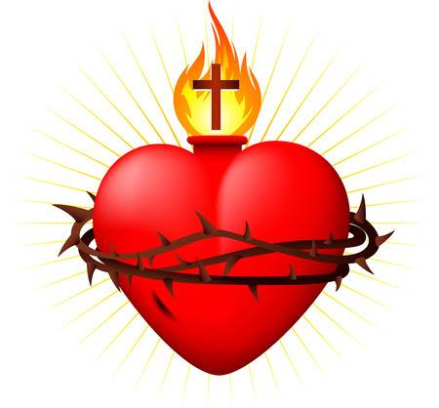 | 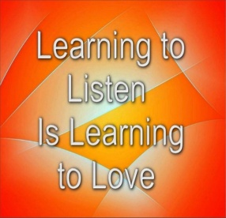 | 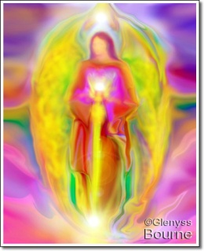
© Calendarpedia® www.calendarpedia.com |  |  |  |  |  | Data provided 'as is' without warranty

