August 2018-
God walks with us every step of the way—every day!
Sunday | Monday | Tuesday | Wednesday | Thursday | Friday | Saturday
 |  |  | 1 | 2 | 3 | 4
We join our prayers as one for the parish, the country and the world. | 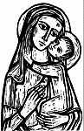 | PRAY | St. Alphonsus  For all who have asked us to pray for them | For all couples who are preparing for marriage | First Friday  For the grace to be forgiving to anyone who has offended us. | St. John Vianney  For all priests, especially those at St.  Ephrem Parish
5 | 6 | 7 | 8 | 9 | 10 | 11
For all the children of the world…for their health, security and faith. | The Transfiguration of the Lord  In thanksgiving for all graces we have received. | For all who are caring for a loved one who is sick | St. Dominic  For all who are living in nursing homes/assisted living residences | For all first responders, firefighters, police and EMTs,for their safety | St. Lawrence  For all workers who are involved in construction, for their safety | St. Clare  For the Poor Clare sisters, for vocations to the contemplative life.
12 | 13 | 14 | 15 | 16 | 17 | 18
For all those who are struggling with an addiction of any type. | For our military, especially those who are in dangerous situations. | St. Maximillian Kolbe  For peace in the world | ASSUMPTION OF MARY  Ask Mary to give peace to our families. | For all who are undergoing treatments for cancer and for those who support them | For all of us that we will readily accept and respect those who are different from us | Ask Mary to protect all the unborn and all expectant parents.
19 | 20 | 21 | 22 | 23 | 24 | 25
For our teachers who are preparing for a new school year | St. Bernard  For a solution to be found to regulate gun control in our cities | St. Pius X  For a greater awareness of our need for the Eucharist in our lives. | The Queenship of Mary  For a greater readiness to go to Mary with all our concerns | St. Rose of Lima  For all  missionaries | St. Bartholomew  For youth that are considering a religious vocation | For all Eucharistic Ministers from St. Ephrem Parish
26 | 27 | 28 | 29 | 30 | 31
For all resident in Oaks Nursing Home | St. Monica  For all mothers of children who are separated from their faith | St. Augustine  For all young people who are confused in their faith | The Passion of. John the Baptist- for all who are suffering due to their faith | For safety of children who are returning to school during these days. | For the grace to be better followers of Jesus. | 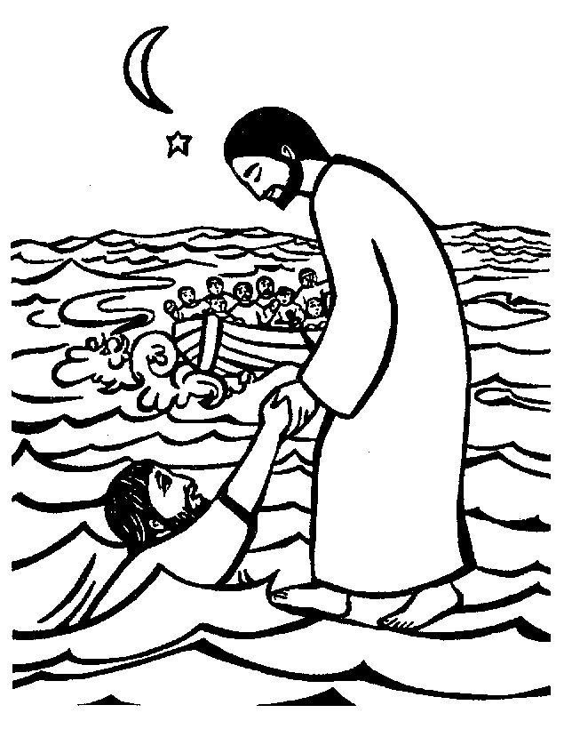
© Calendarpedia® www.calendarpedia.com |  |  |  |  |  | Data provided 'as is' without warranty

