May 2018
Sunday | Monday | Tuesday | Wednesday | Thursday | Friday | Saturday
29 | 30 | 1 | 2 | 3 | 4 | 5
May is the traditional month to remember to honor Mary, the mother of Jesus. Pray the rosary for your special intentions. | 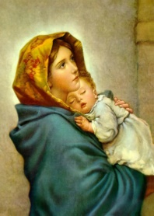 | Pray for Mary’s guidance in your life and the lives of your loved ones. | For Expectant Mothers and their unborn children. | We pray for all those affected by violence and war | First Friday  For a greater  Trust in the Love of Jesus for you.  Sacred Heart of Jesus. I trust in you! | First Saturday  Mary, mother of the forgotten, help all children who are lost and alone and abandoned.
6 | 7 | 8 | 9 | 10 | 11 | 12
For our St. Ephrem parish family…for an increase of vocations from St. Ephrem’s | We pray for all priests that they will continue to grow in their fidelity to their callings | For all Bensalem firefighters-for their safety and in gratitude for their service. | For all members of our parish family who are sick and homebound | For all children at St. Ephrem’s School and their teachers | For all the children who attend St. Ephrems PREP and their teachers | For members of the Teen Group of St. Ephrems-and their families
13 | 14 | 15 | 16 | 17 | 18 | 19
Mother’s Day  For all Mothers, both living and deceased, in gratitude for their care for us. | For all Bensalem  Police men and women—for their safety and for all EMS persons who stand ready to help every day. | For our Pope Francis and all bishops—for their perseverance in living the Gospel. | For our parish members who have recently died and for those who mourn for them. | For all of our parish members who are hospitalized or in rehabilitation centers. | For all the imprisoned and for those who work closely with each of them. | For all who are in Nursing Homes or in Assisted Living Residence that they are comfortable and at peace.
20 | 21 | 22 | 23 | 24 | 25 | 26
Pentecost Sunday  Ask the Holy Spirit to come to you anew and bring the gifts and fruits of the Spirit to you. | Notice the spring flowers---let yourself speak of gratitude to God for the beauty of creation. | Listen to the song of the birds today.  Thank God for the gift of hearing.  Ask a special blessing on all the deaf people. | Remember in prayer Monsignor and Father Katziner today. Thank God for their ministry with us. | Thank god for all the children baptized this month at St. Ephrems. Ask God’s blessing on their parents. | Ask God to keep our families safe this coming holiday weekend—that families may be at peace and be safe. | Remember to pray especially for all who gave their lives defending our United States of America.
27 | 28 | 29 | 30 | 31
“Do not be anxious… the peace of God will guard your heart.” ~  Phil. 4:6-7 | Memorial Day  For all of our families today for peace and safe travels. | NOTICE HOW KIND PEOPLE ARE TO YOU TODAY…PASS IT ON. | PHONE A FRIEND TODAY | Feast of the Visitation  That we will welcome all people that come across our path today. |  | 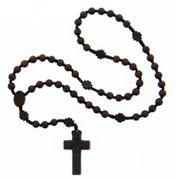
© Calendarpedia® www.calendarpedia.com |  |  |  |  |  | Data provided 'as is' without warranty

